Byron W. Brown
Mayor

POLICE ATHLETIC LEAGUE

OF BUFFALO, INC
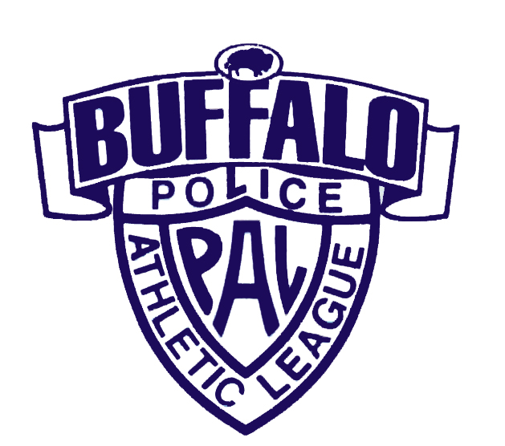
TEAM/COACH REGISTRATION FORM DATE______/______/______

PLEASE MAIL BACK A.S.A.P WITH YOUR PAYMENT

PLEASE CHECK:
__________________________________________________________________________________________________________________

FEE: $295.00
10 & under □BOYS Age Cutoff January 1, 2020
__________________________________________________________________________________________________________________

FEE: $295.00
12 & under □BOYS □GIRLS Age Cutoff January 1, 2020
__________________________________________________________________________________________________________________

FEE: $295.00
14 & under □BOYS 15 & Under □GIRLS Age Cutoff January 1, 2020
__________________________________________________________________________________________________________________

FEE: $295.00
16 & under □BOYS 19 & Under □BOYS Age Cutoff January 1, 2020

TEAM NAME________________________________________________________________________

COACHES NAME____________________________________________________________________

ADDRESS__________________________________________________________________________

CITY____________________________________STATE________________ZIP__________________

PHONE___________________CELL__________________EMAIL_____________________________
TEAM FEE INCLUDED: □YES □NO
CHECK#____________ MADE PAYABLE TO: PAL
□ CREDIT CARD PAYMENT WAS PHONED IN TO 851-4615

REMINDER: ALL FEES MUST BE PAID BY December 13th, 2019. NO EXCEPTIONS WILL BE MADE.

MAIL COMPLETED APPLICATION & CHECK TO: PAL of Buffalo
65 Niagara Square, 21st Floor
Orv Cott - Cell Phone #812-7251 Buffalo, NY 14202

Upon receipt of payment and Team/Coach Registration Form, the following package will be sent to you including:

- Team Roster
Schedules will be presented in package
for entire team at 1st game.
Teams will be notified verbally for 1st game.
- Individual Player Forms
- Rules

