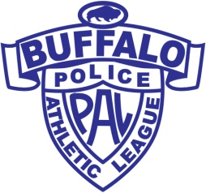
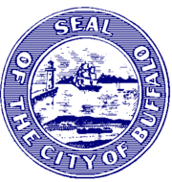
12/28 Boys 12 & Under
BYRON W. BROWN
Mayor

@ MACHNICA CENTER 1799 CLINTON
1. AYB McCARTHY 5. LAKESHORE
2. HAMBURG PIRATES 6. AYB BUCKINGHAM
3. BRAVES 7. COLLEGE BOUND
4. LINCOLN 8.EAST SIDE ELITE

**** REVISED 12/28*** REVISED 12/28****
1/4 1/11 1/18 1/25 2/1 2/8 2/15
9:55 1-2 1-5 1-4 1-6 1-3 1-8 1-7
12:40 3-8 4-6 2-6 2-3 6-7 3-6 6-8
1:35 5-6 3-7 7-8 5-7 5-8 4-5 2-5
2:30 4-7 2-8 3-5 4-8 2-4 2-7 3-4
2/22 2/29 3/7
11:00 3rd -6th 11:00 1st-Lowest CHAMPIONSHIP
12:00 4th -5th 12:00 2nd- 2nd Low AT 11:00
1:00 2nd ⁻7th
2:00 1st -8th QUESTIONS ORV COTT 812-7251

